Task 1: System Monitoring Setup
Objective
Configure basic system monitoring to ensure health, performance visibility, and capacity planning for a Linux-based development environment.

Scenario
- The development server experiences intermittent performance issues
- Developers require visibility into system resource usage
- System metrics must be tracked consistently for troubleshooting and planning

Tools Used
- htop / nmon – CPU, memory, and process monitoring
- df – Filesystem-level disk usage
- du – Directory-level disk usage
- ps – Process-level resource analysis
- Cron + log files – Reporting and history

Monitoring Setup Steps
1. Install Monitoring Tools
To check CPU usage, memory usage, and running processes, we need to install htop.
On this server, htop is not available in the default repositories.
Therefore, we must first install EPEL (Extra Packages for Enterprise Linux) and then install htop.
yum install epel-release
yum install htop nmon
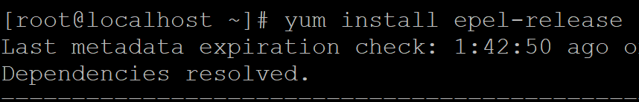

htop
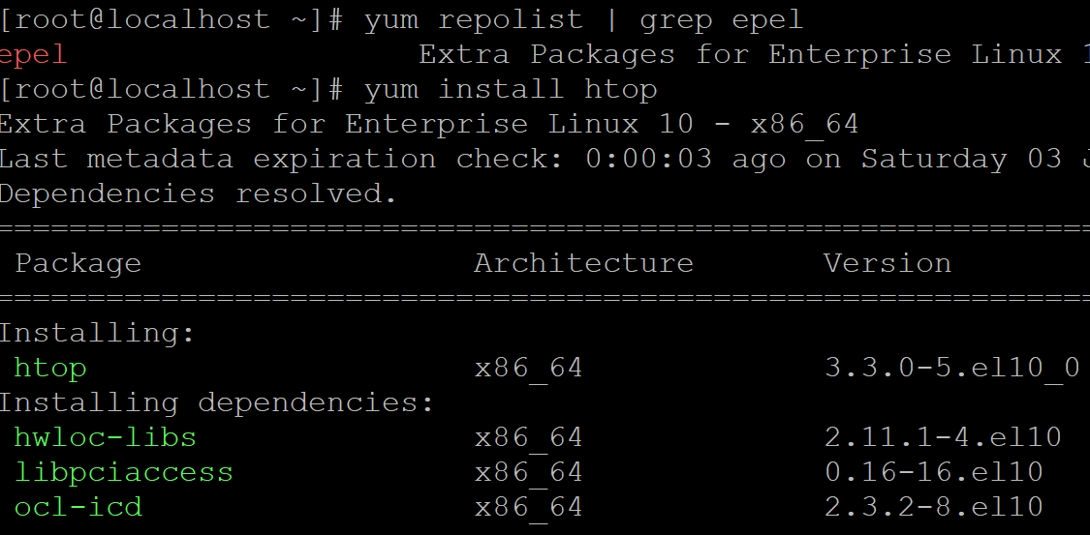
nmon
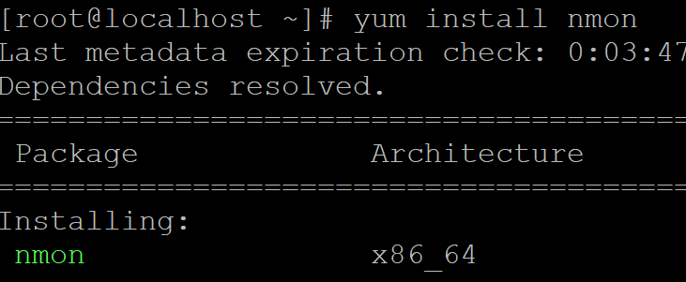

2. CPU, Memory, and Process Monitoring
- htop: Interactive, real-time monitoring
- nmon: Performance and capacity snapshots
htop
nmon
htop output
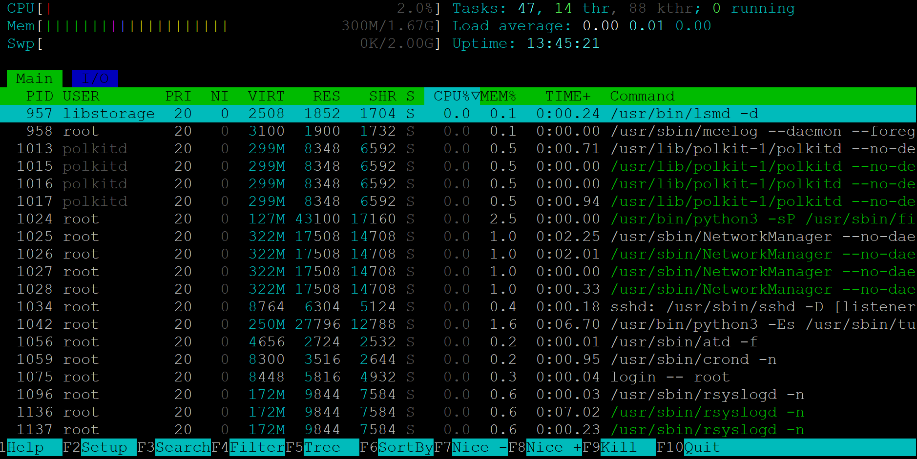
nmon output
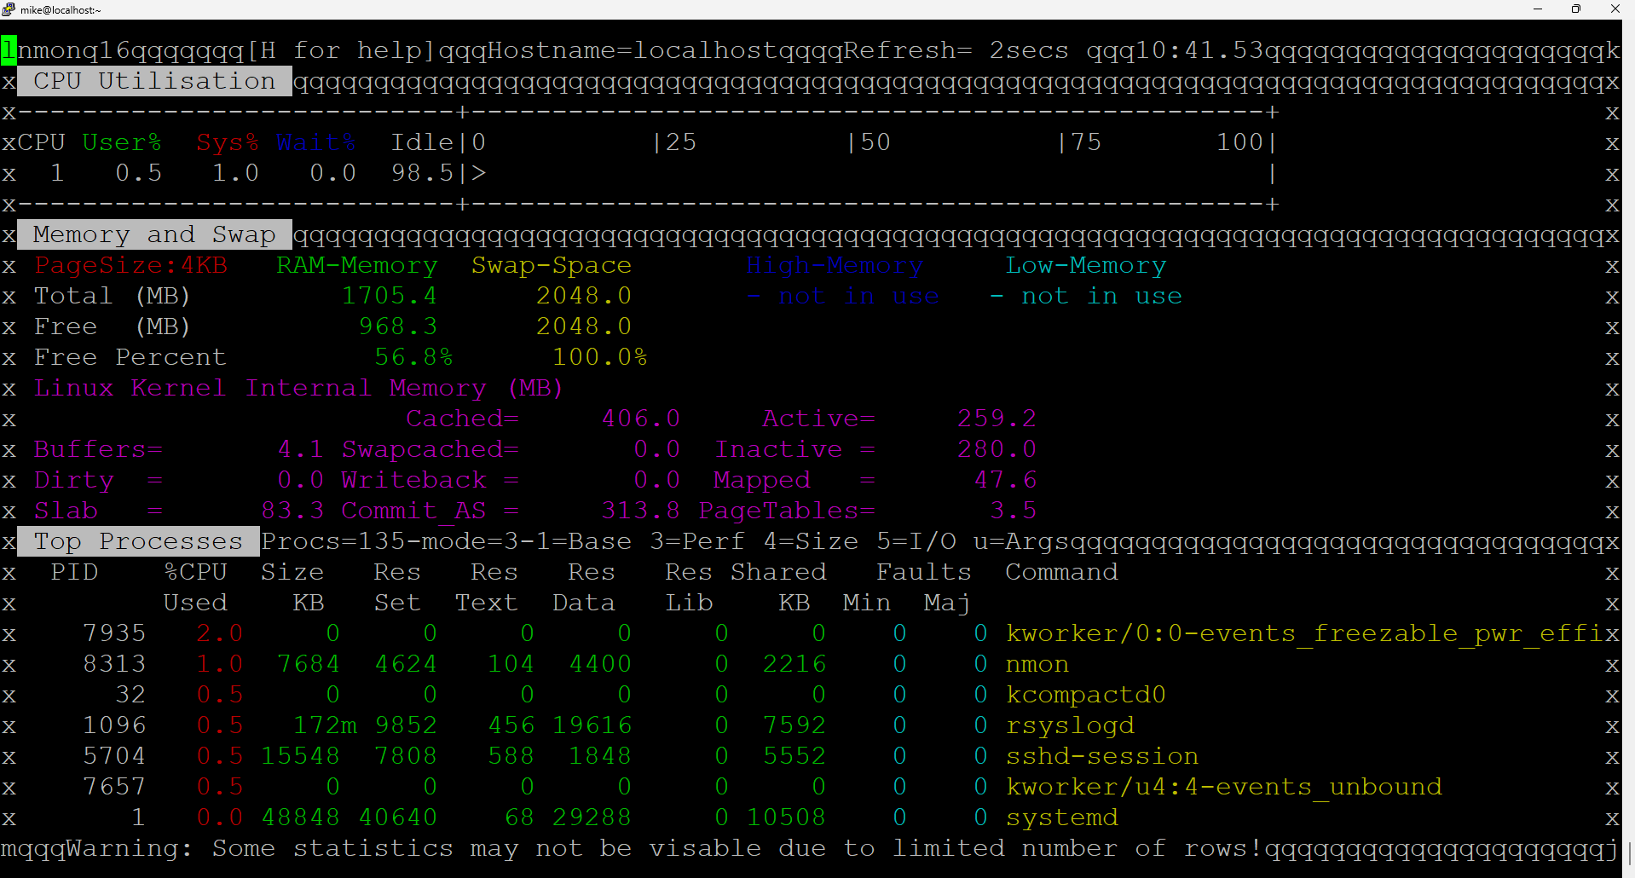

3. Disk Usage Monitoring
Filesystem-level usage:
Disk usage monitoring is required to ensure sufficient storage availability and to support capacity planning.
Purpose of df
- df (Disk Free) is used to monitor filesystem-level disk usage
- It shows total space, used space, and available space for each mounted filesystem
- Helps identify if the disk is nearing full capacity
df -h
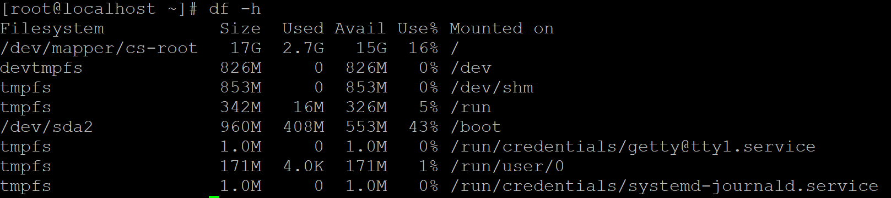
Directory-level usage:
Purpose of du
- du (Disk Usage) is used to monitor directory-level disk consumption
- Helps identify which directories are consuming the most space
- Useful for troubleshooting storage issues
du -h | head
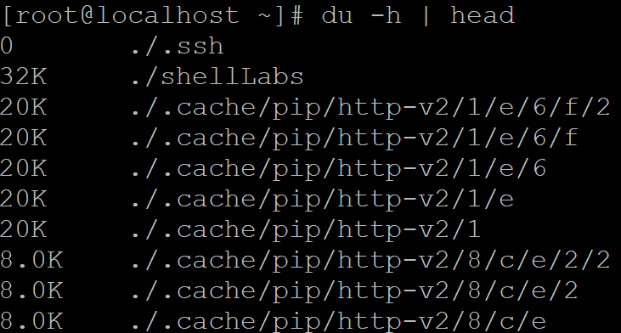
du for home directory
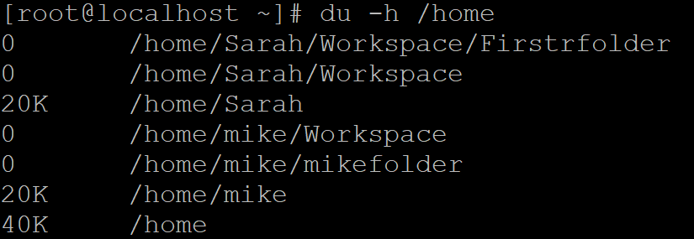

4. Identify Resource-Intensive Processes
To analyze system performance issues, we identify processes that consume the highest CPU and memory resources.
Top CPU consumers:
Below are the top 10 processes that are consuming CPU:
ps -eo pid,user,cmd,%cpu,%mem --sort=-%cpu | head
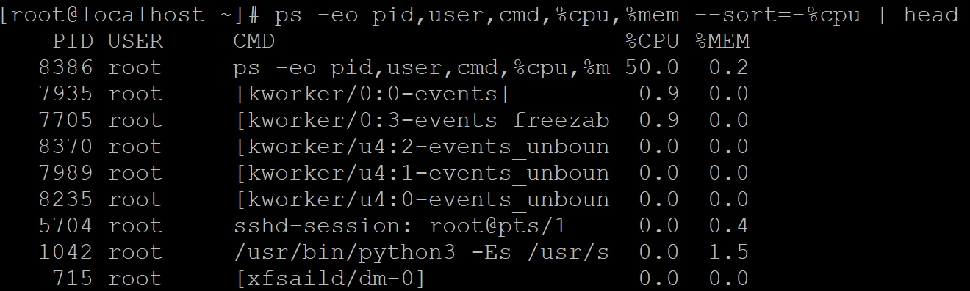
Top Memory consumers:
Below are the top 10 processes that are consuming MEMORY:
ps -eo pid,user,cmd,%mem,%cpu --sort=-%mem | head
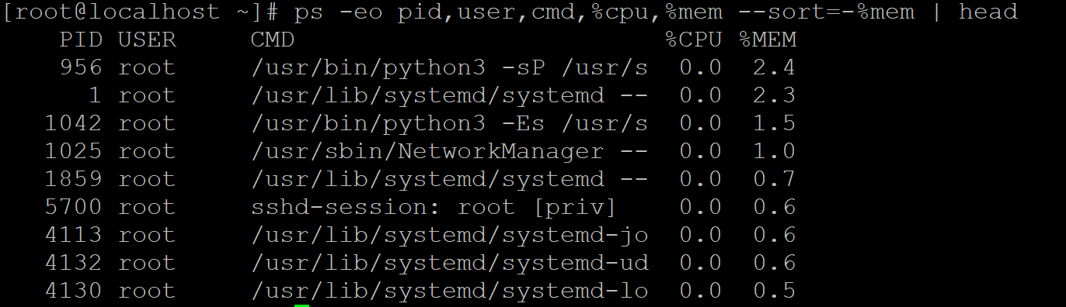

5. Reporting and Logs
To generate system monitoring reports, create a dedicated directory and store all reports in one centralized location.
mkdir -p /var/log/system-monitoring
Generate reports:
df -h > /var/log/system-monitoring/disk_report.log
ps -eo pid,user,cmd,%cpu,%mem --sort=-%cpu | head >> /var/log/system-monitoring/process_report.log
disk_report 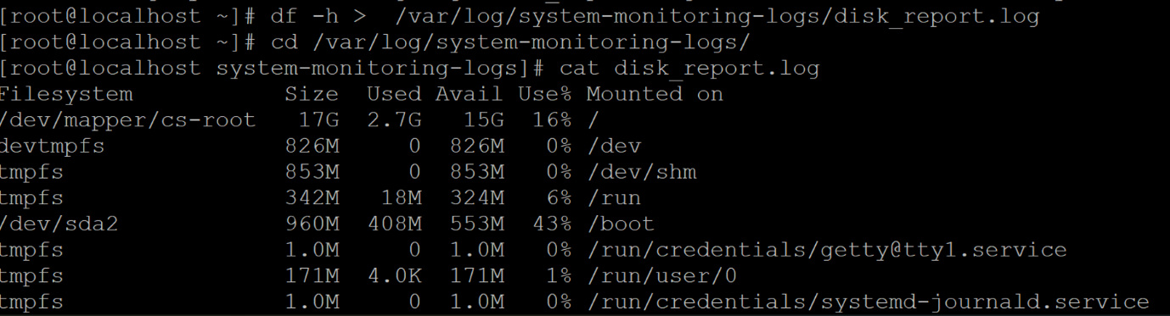
process_report 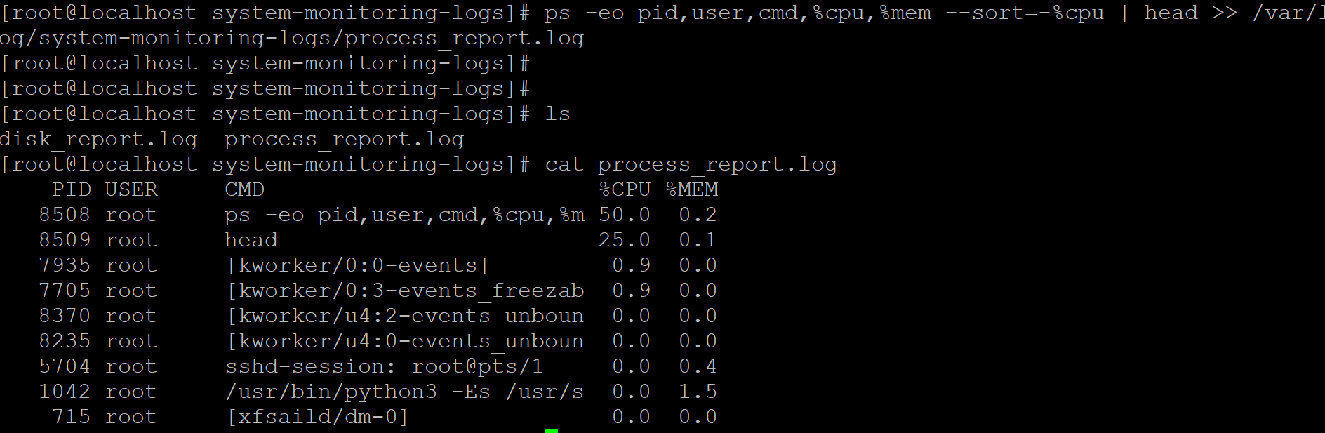
Outcome
- Real-time visibility into CPU, memory, disk, and processes
- Ability to identify performance bottlenecks quickly
- Logged data for historical analysis and capacity planning

Conclusion
This setup provides a lightweight yet effective monitoring baseline, suitable for development environments and early-stage production systems.

Task 2: User Management and Access Control
Objective
Set up secure user accounts and access controls for new developers to ensure isolation, security, and proper password management.

Scenario
- Two new developers, Sarah and Mike, require system access
- Each developer must have an isolated working directory
- Password policies must enforce security and expiration
- Access to directories must follow the principle of least privilege

1. Create User Accounts
Create user accounts for Sarah and Mike with home directories.
useradd Sarah
useradd mike
Verfiy Users Creation
id Sarah
id mike
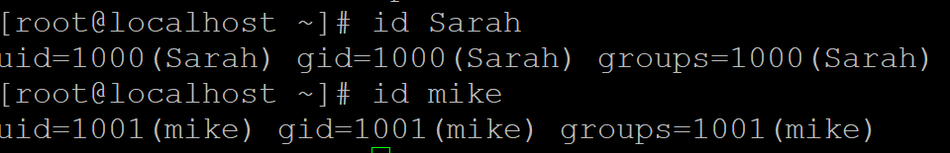
Check in home directory
cd /home
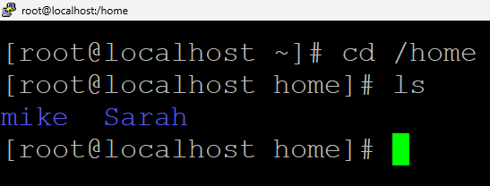
2. Set Secure Passwords
Assign passwords for both users.
passwd Sarah
passwd mike
Sarah
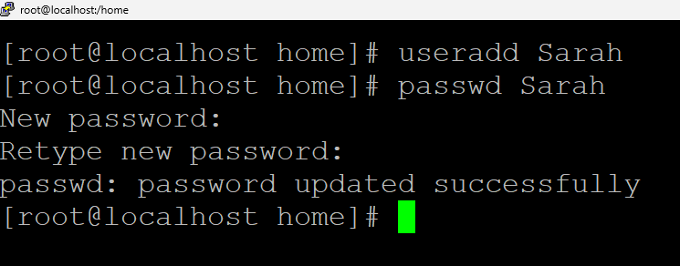
Mike
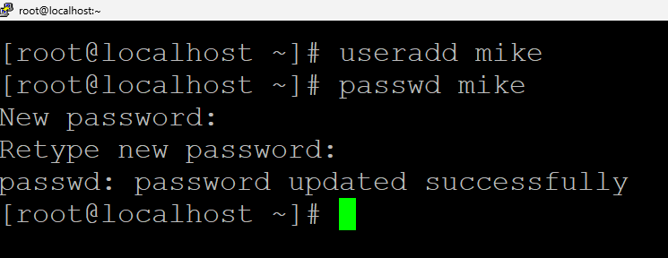

3. Create Dedicated Workspace Directories
Each user is provided with a dedicated workspace directory to ensure isolation.
mkdir -p /home/Sarah/workspace
mkdir -p /home/mike/workspace
Assign ownership:
sudo chown -R Sarah:Sarah /home/Sarah/workspace
sudo chown -R mike:mike /home/mike/workspace

4. Apply Secure Permissions
Restrict access so that only the respective user can access their workspace.
chmod 700 /home/Sarah/workspace
chmod 700 /home/mike/workspace
Permission 700 ensures:
- Owner: full access
- Group & Others: no access

5. Enforce Password Expiration Policy
To improve security, enforce a password expiration policy of 30 days.
chage -M 30 Sarah
chage -M 30 mike
Verify password policy:
chage -l Sarah
chage -l mike
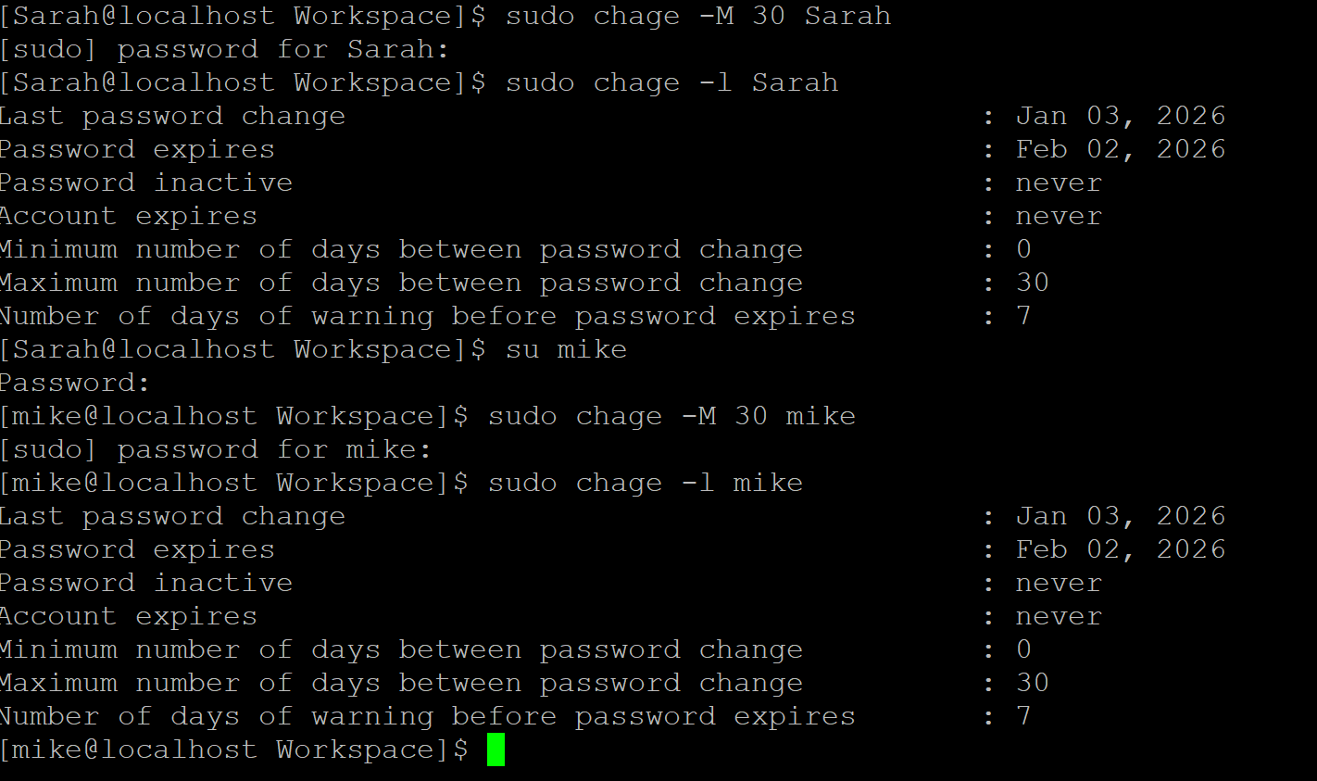

6. Grant Sudo Access Using visudo
To allow Sarah and Mike to perform administrative operations securely, sudo access is granted using the visudo command.
The visudo utility is used because it:
- Safely edits the sudoers file
- Performs syntax validation before saving
- Prevents misconfiguration that could lock out administrative access
visudo
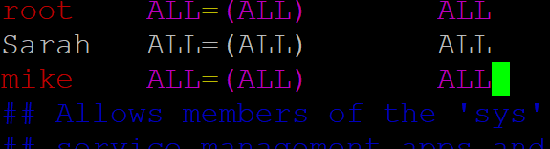
7. Verify User Isolation and Access Control
To validate that user access restrictions are working correctly, switch to the Sarah user and perform access tests.
Switch to Sarah:
su Sarah
Create a new directory inside Sarah’s workspace:
sudo mkdir Firstfolder
This operation succeeds because Sarah owns her workspace.
Next, attempt to create a directory inside Mike’s workspace:
sudo mkdir /home/mike/workspace/mike_folder
This operation fails with a Permission denied error, confirming that:
- Sarah does not have access to Mike’s workspace
- User isolation and directory permissions are enforced correctly

Purpose of This Verification
- Confirms least-privilege access
- Prevents unauthorized data access
- Validates correct permission configuration

One-Line Summary
This step proves that each user can access only their own workspace, ensuring strong isolation and security.
Outcome
- Secure user accounts created for Sarah and Mike
- Isolated workspaces with strict access controls
- Passwords enforced with expiration and warnings
- System follows enterprise Linux security best practices

Conclusion
This task establishes a secure and scalable user management foundation, suitable for development environments and compliant with standard Linux security practices.

Task 3: Backup Configuration for Web Servers
Objective
Configure automated backups for Apache and Nginx web servers to ensure data integrity, disaster recovery, and audit readiness.

Scenario
- Sarah manages an Apache web server
- Mike manages a Nginx web server
- Both servers require regular automated backups
- Backups must include configuration files and document roots
- Backup integrity must be verified after each run

Prerequisite: Verify Web Servers Installation
Before working on the Task , ensure that Apache and Nginx are installed on the server.
Backup scripts depend on the presence of their respective configuration and document root directories.
- To install Apache and Nginx servers , use below commands
Apache
yum install httpd
Nginx
yum install nginx
Verify Apache Installation
ls /etc | grep httpd
Verify NGINX Installation
ls /etc | grep nginx
1. Create Centralized Backup Directory
Create a secure directory to store all backup files.
mkdir -p /backups
This ensures:
- Backups are stored centrally
- Only root can modify backup data

2. Create Apache Backup Script (Sarah)
Create the Apache backup script:
nano /usr/local/bin/apache_backup.sh
Script content:
#!/bin/bash

DATE=$(date +%F)
BACKUP_FILE="/backups/apache_backup_${DATE}.tar.gz"
LOG_FILE="/backups/apache_backup_verify.log"

tar -czf $BACKUP_FILE /etc/httpd /var/www/html

echo "[$(date)] Verifying Apache backup" >> $LOG_FILE
tar -tzf $BACKUP_FILE >> $LOG_FILE
echo "-----------------------------------" >> $LOG_FILE
To make the script executable for all the users, use below command
chmod +x /usr/local/bin/apache_backup.sh

3. Create Nginx Backup Script (Mike)
Create the Nginx backup script:
nano /usr/local/bin/nginx_backup.sh
Script content:
#!/bin/bash

DATE=$(date +%F)
BACKUP_FILE="/backups/nginx_backup_${DATE}.tar.gz"
LOG_FILE="/backups/nginx_backup_verify.log"

tar -czf $BACKUP_FILE /etc/nginx /usr/share/nginx/html

echo "[$(date)] Verifying Nginx backup" >> $LOG_FILE
tar -tzf $BACKUP_FILE >> $LOG_FILE
echo "-----------------------------------" >> $LOG_FILE
To make the script executable for all the users use below command
chmod +x /usr/local/bin/nginx_backup.sh

4. Schedule Automated Backups Using Cron
Edit root crontab:
crontab -e
Add the following entries to run backups every Tuesday at 12:00 AM:
0 0 * * 2 /usr/local/bin/apache_backup.sh
0 0 * * 2 /usr/local/bin/nginx_backup.sh

5. Manual Backup Verification
Run the scripts manually to validate functionality:
/usr/local/bin/apache_backup.sh
/usr/local/bin/nginx_backup.sh
Verify backup files:
ls -lh /backups
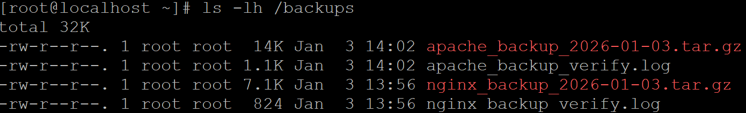

6. Backup Integrity Verification
Verify backup contents using log files:
cat /backups/apache_backup_verify.log
cat /backups/nginx_backup_verify.log
apache_backup_verify
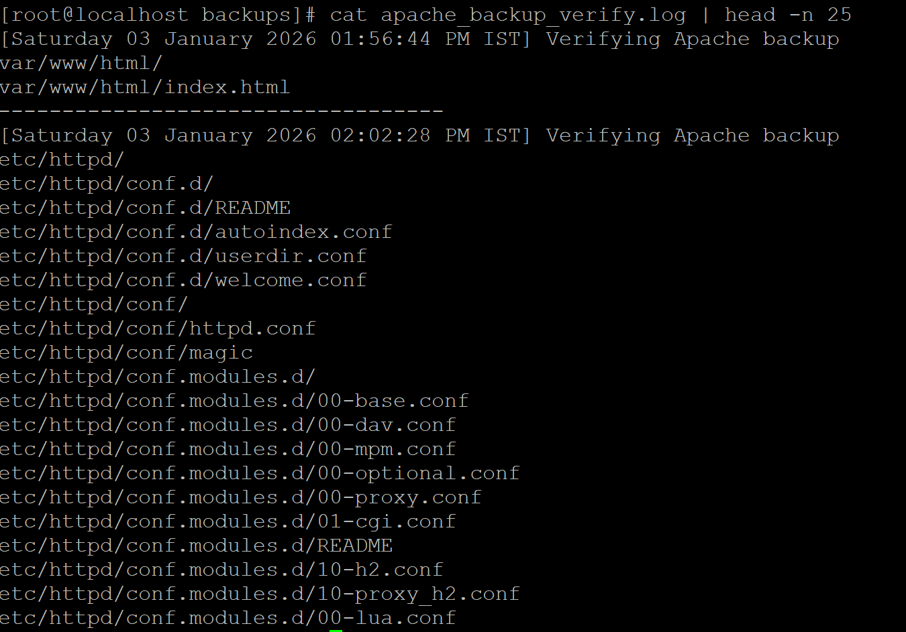
nginx_backup_verify
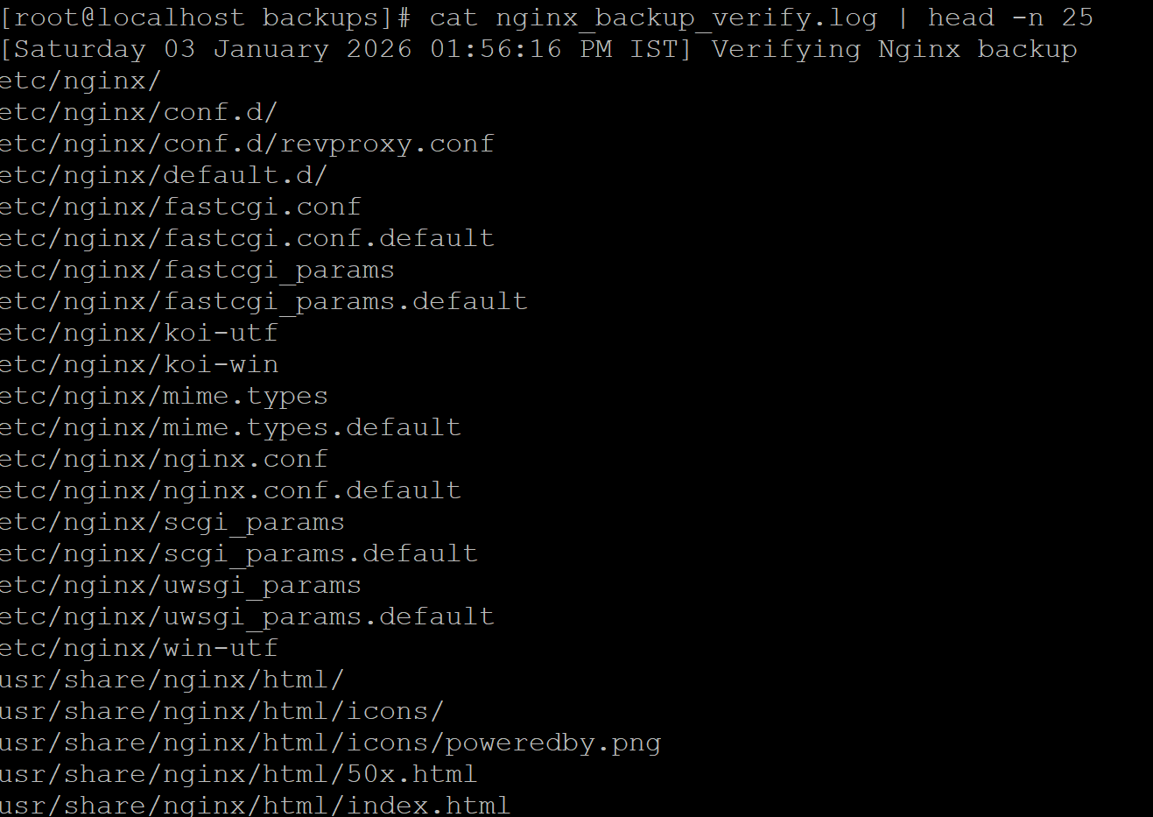
These logs confirm:
- Backup archive is readable
- Files are correctly included
- Backup integrity is validated

Outcome
- Automated weekly backups configured
- Configuration and web content protected
- Backup integrity verified after each run
- Secure and production-ready backup system implemented

Conclusion
This task implements a reliable, secure, and automated backup strategy for Apache and Nginx servers, ensuring operational resilience and disaster recovery readiness.

